Prediction of Admission in Engineering College

In this project you ask to predict college admission for engineering or college students using machine learning algorithms and you ask us to implement following modules

1. Admin Module: admin can login to system using username and password as ‘admin’ and ‘admin’ and then load dataset and then train dataset with various machine learning algorithms called Random Forest, SVM and Decision Tree. There are 100’s of colleges and it’s not possible for admin to add all those colleges so we are using dataset which contains more than 50000 colleges details.
2. User module: user can signup with the application and then login and then can predict college by entering their academic profiles as input. Input values are Eamcet Rank, Gender, Caste, University and branch (engineering, pharmacy etc.)

Below screen showing dataset details used for machine learning algorithms training

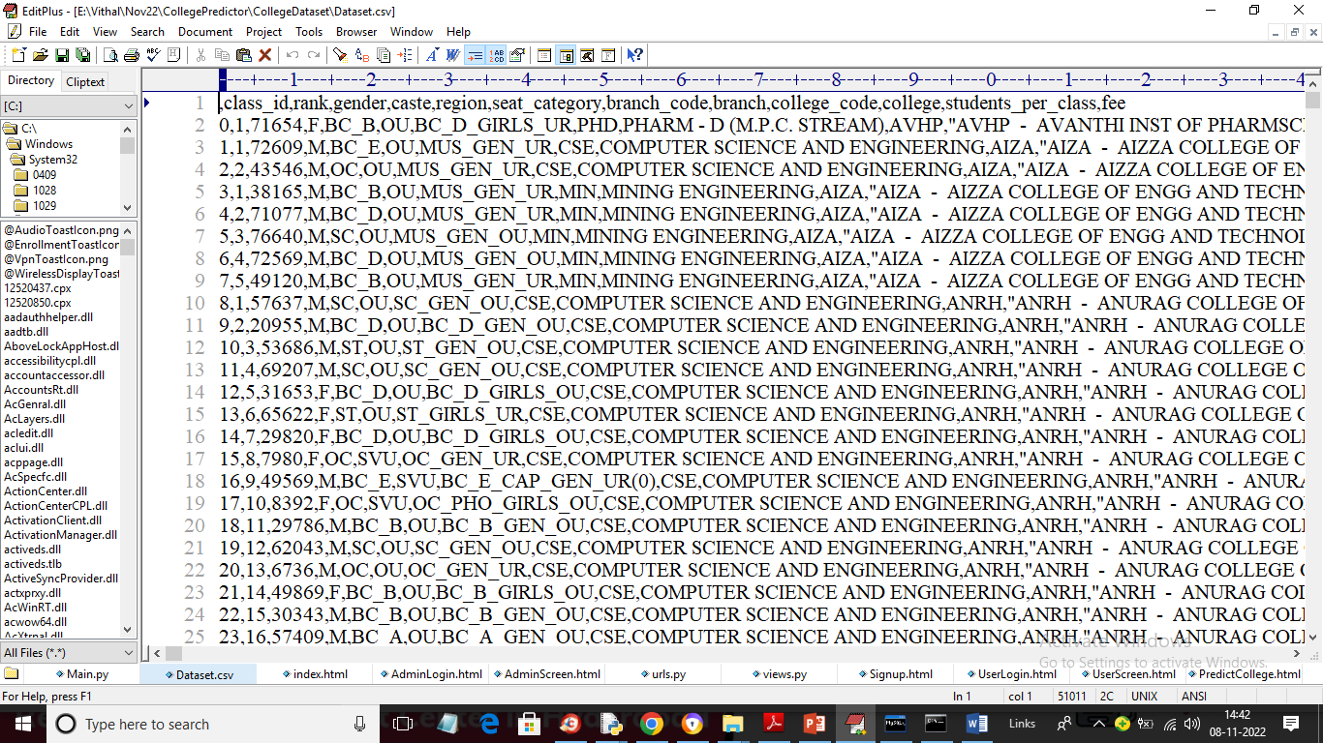

In above dataset screen first rows contains dataset column names and remaining rows contains dataset values and each row contains Rank, gender, caste and college name with branch details and by using above dataset admin will train ML algorithms.

SCREEN SHOTS

To run project double click on ‘run.bat’ file to start python WEB SERVER and below screen

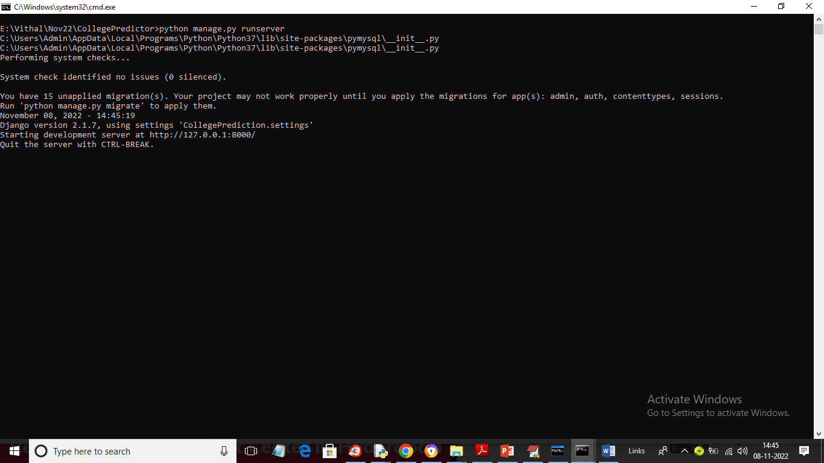

In above screen python web server started and now open browser and enter URL as <http://127.0.0.1:8000/index.html> and press enter key to get below page

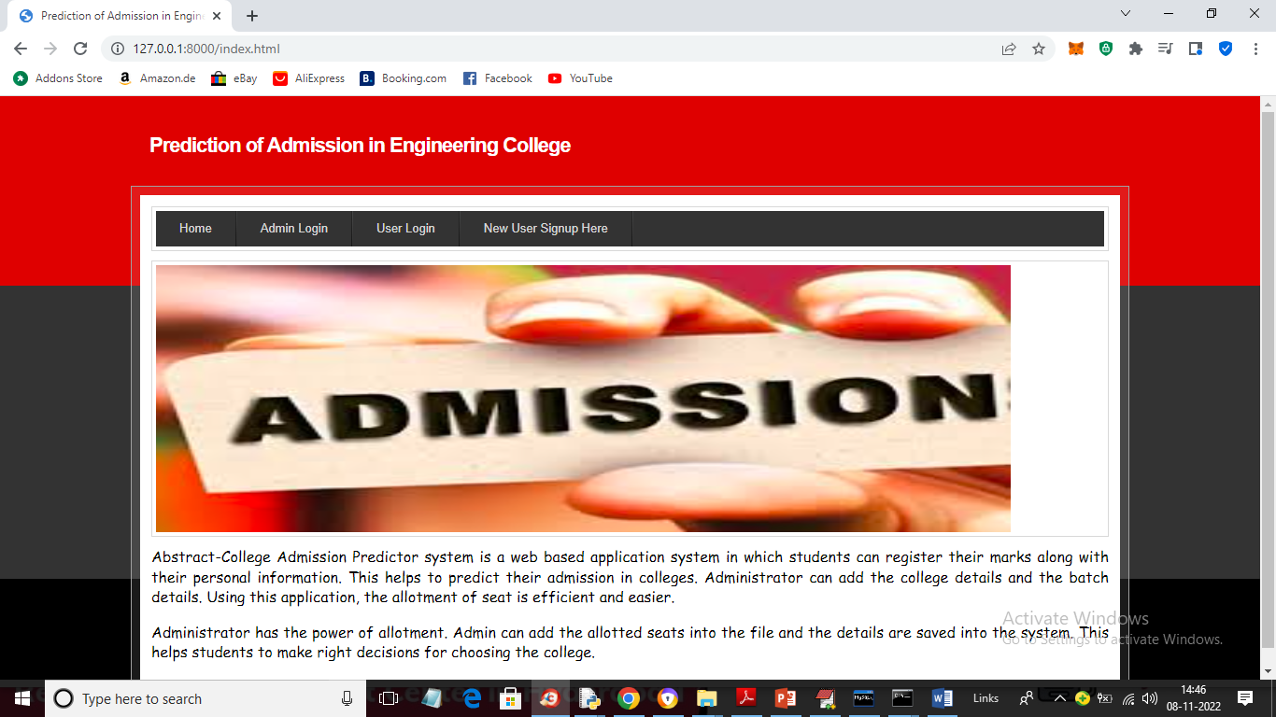

In above screen click on ‘Admin Login’ link to get below admin login screen

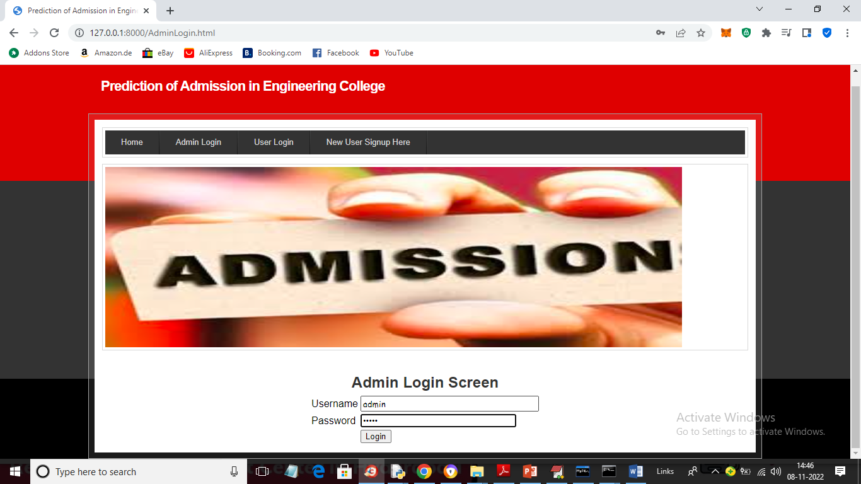

In above screen admin is login and after login will get below screen

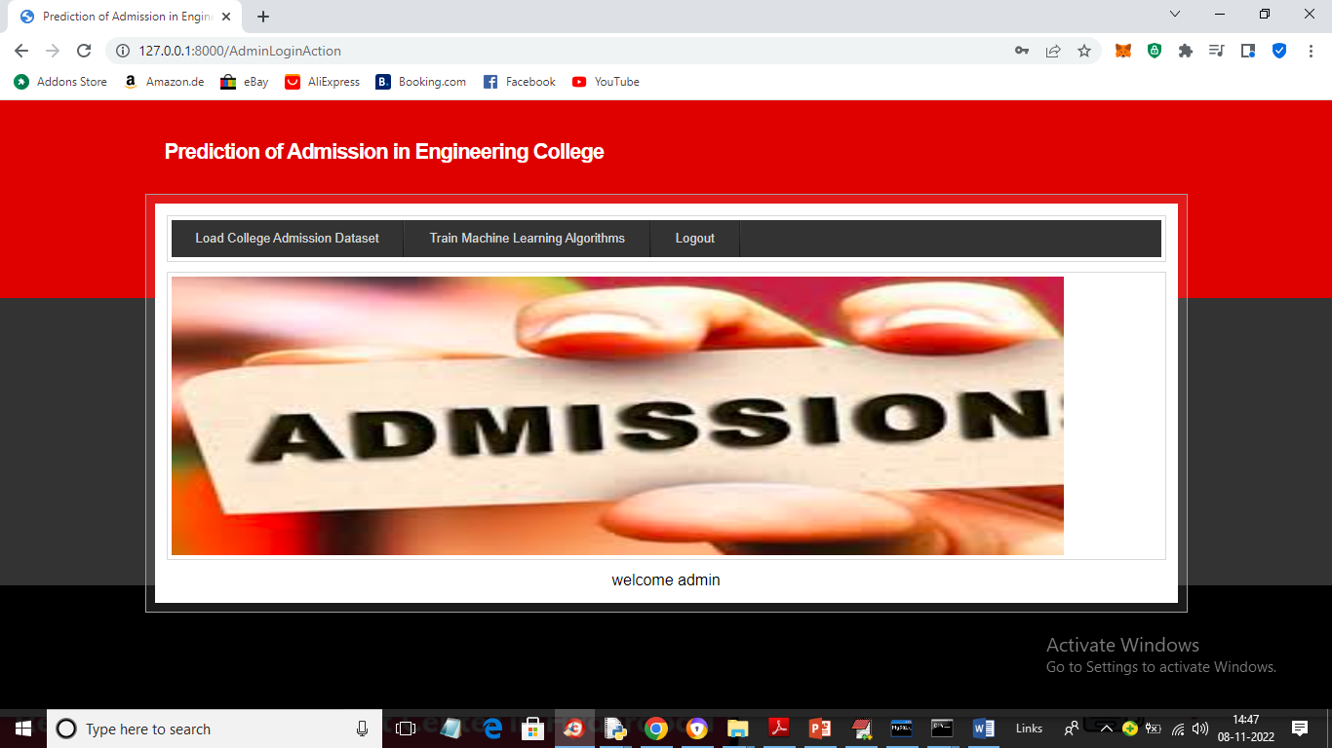

In above screen we got admin HOME page and then click on ‘Load College Admission Dataset’ link to load dataset and get below output

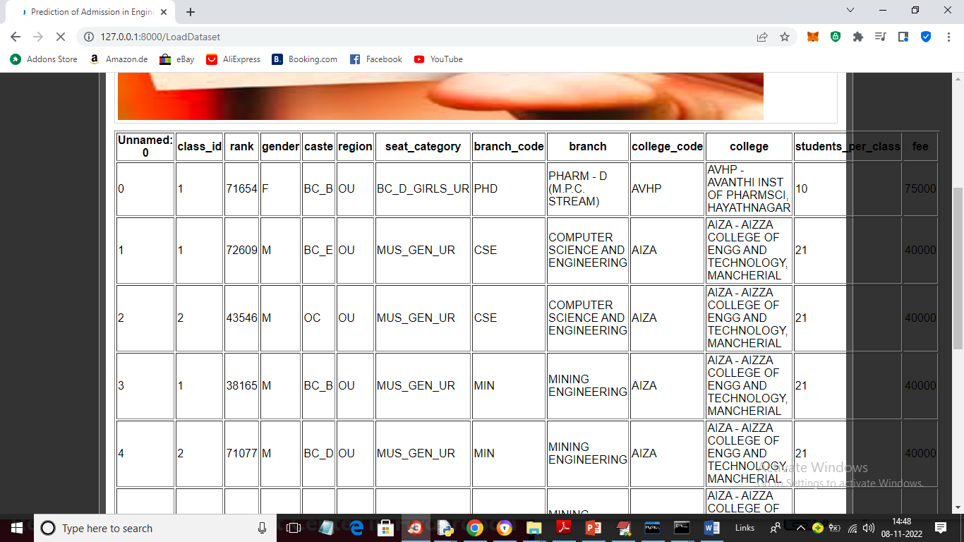

In above screen dataset loaded to application and now click on ‘Train Machine Learning Algorithms’ button to train algorithms and get below output

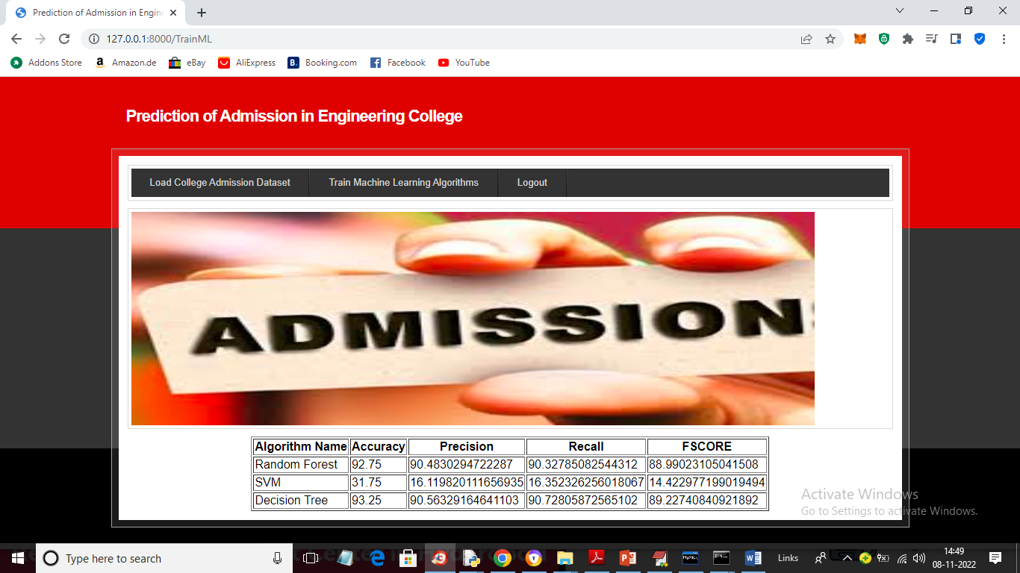

In above screen training is completed and we got metrics output from all algorithms such as accuracy, precision, recall and FSCORE and in all algorithms decision tree got highest accuracy as 93% and now algorithms training is completed and users can use this algorithms mode to predict colleges. Now click on ‘Logout’ button and signup one user

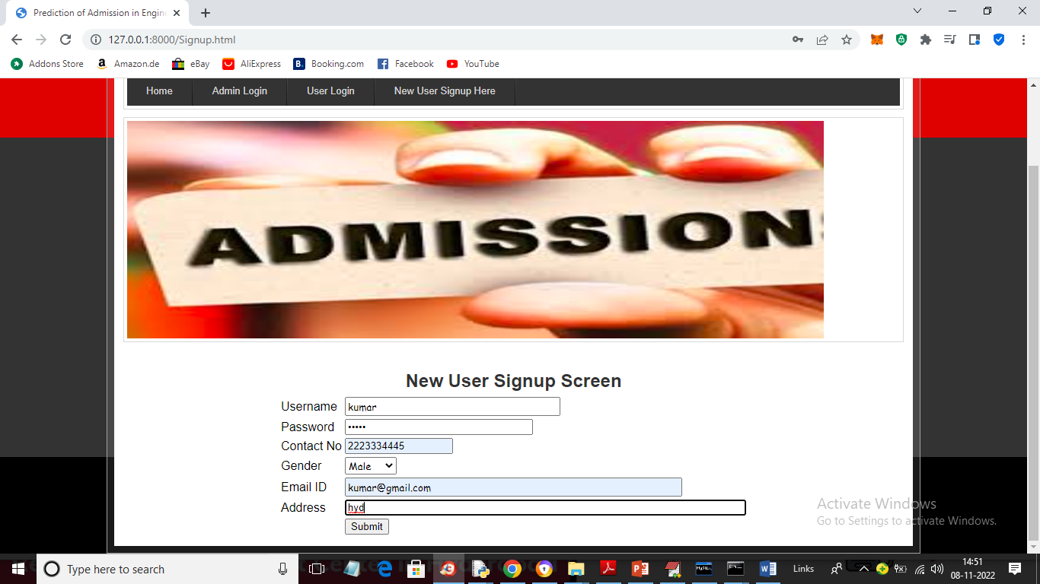

In above screen user is signing up by entering details and now click on ‘Submit’ button to complete signup process and get below output

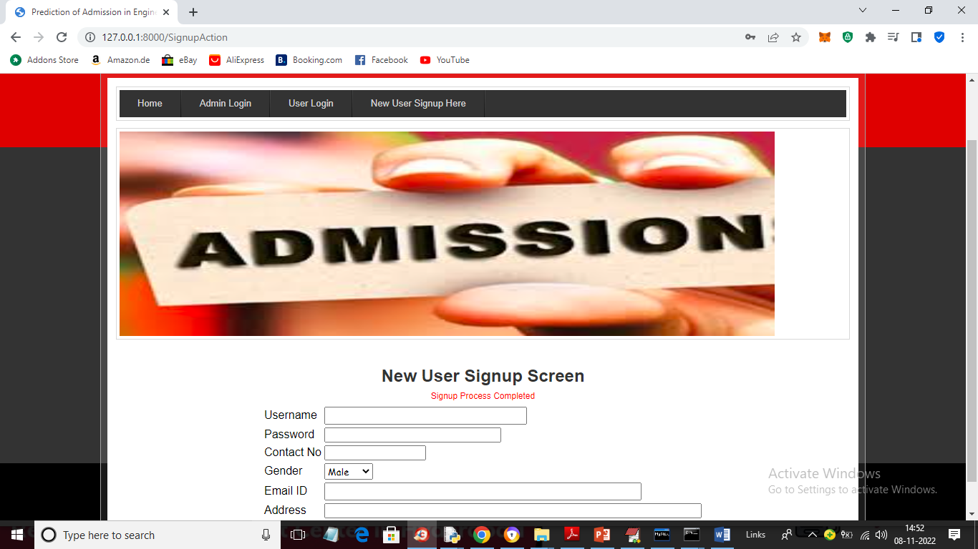

In above screen signup is completed and now click on ‘User Login’ link to get below login screen

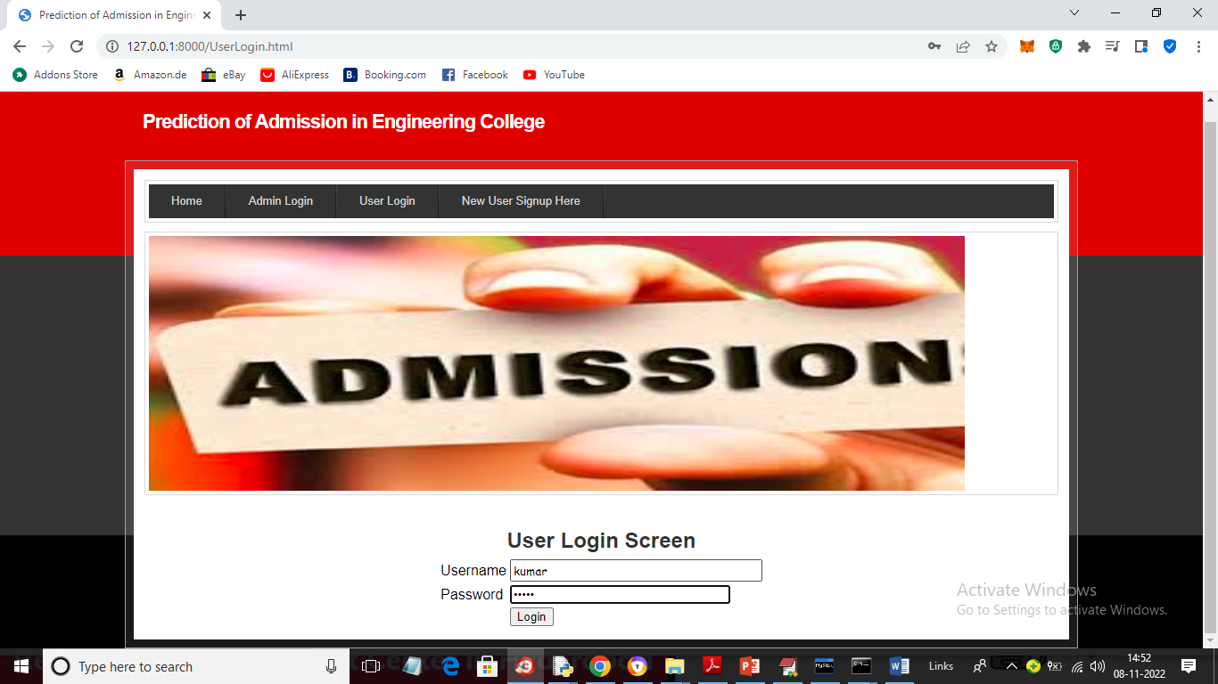

In above screen user is login and after login will get below output



In above screen click on ‘Predict Your Admission College’ link to get below screen

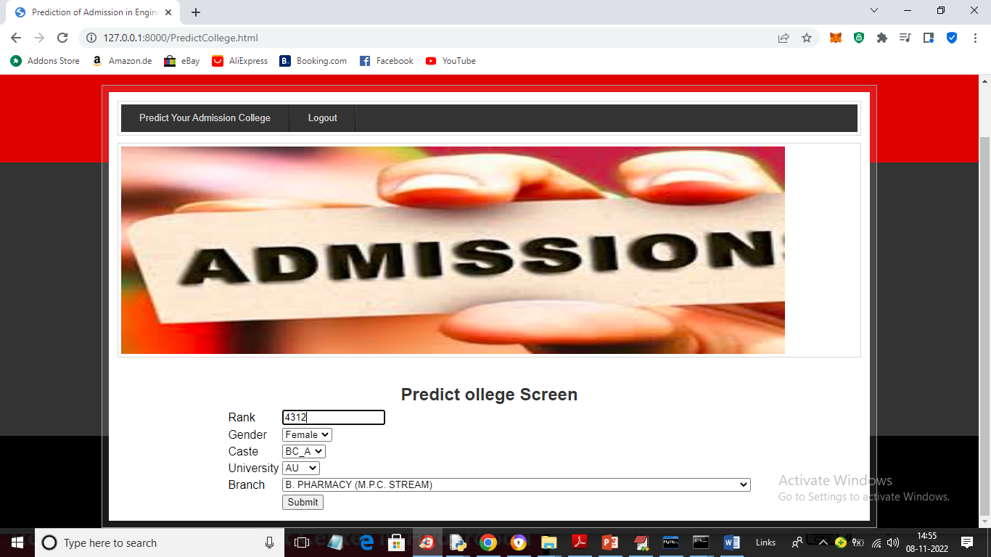

In above screen user will enter his Rank and select desired details like Gender, Caste, university and branch and press button to get predicted college

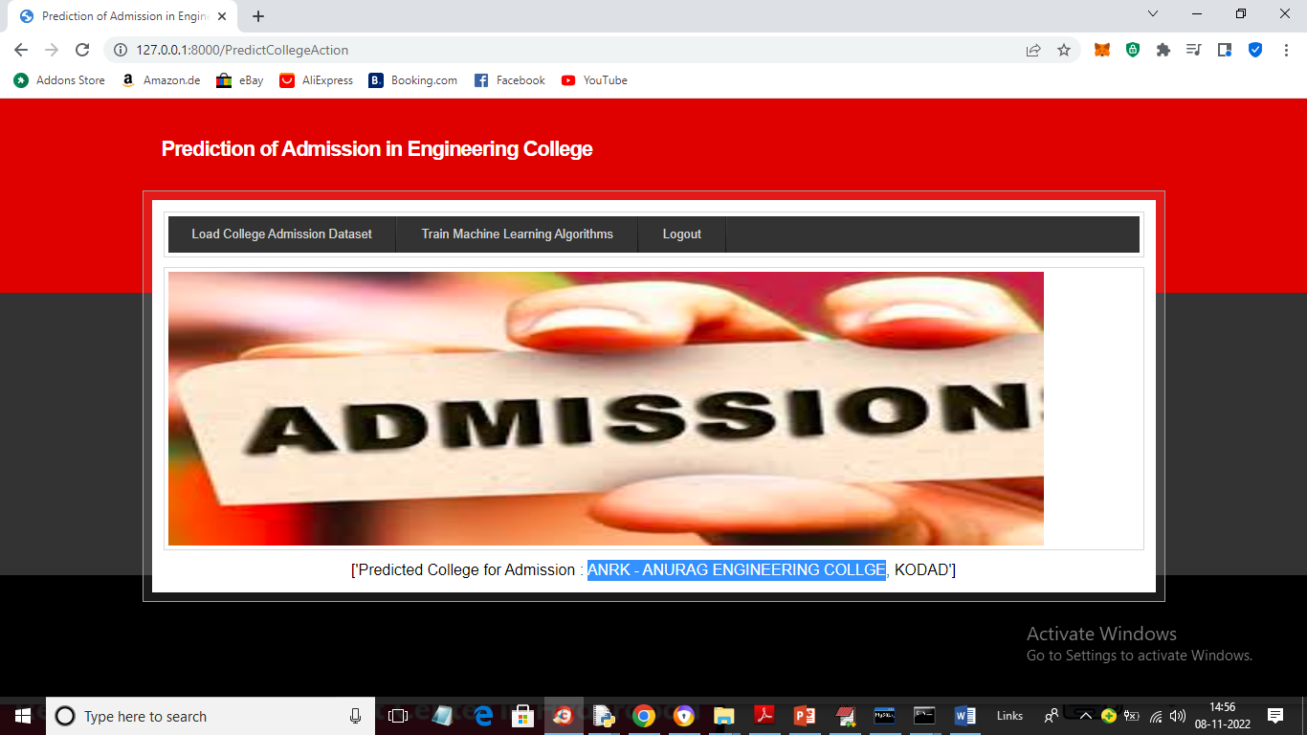

In above screen in blue colour text we can see predicted college is ‘Anurag Engineering College’ and similarly you can enter details and get predicted college and in below screen I am trying new test data

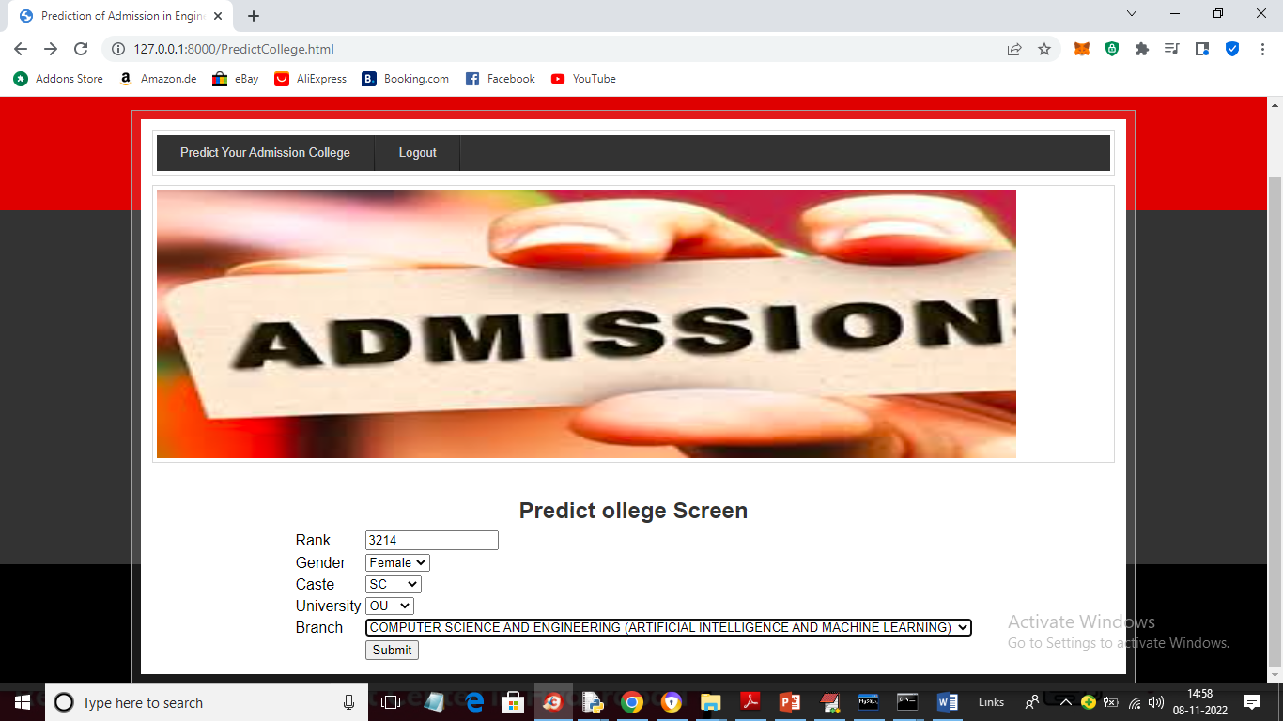

For above screen input will get below predicted college

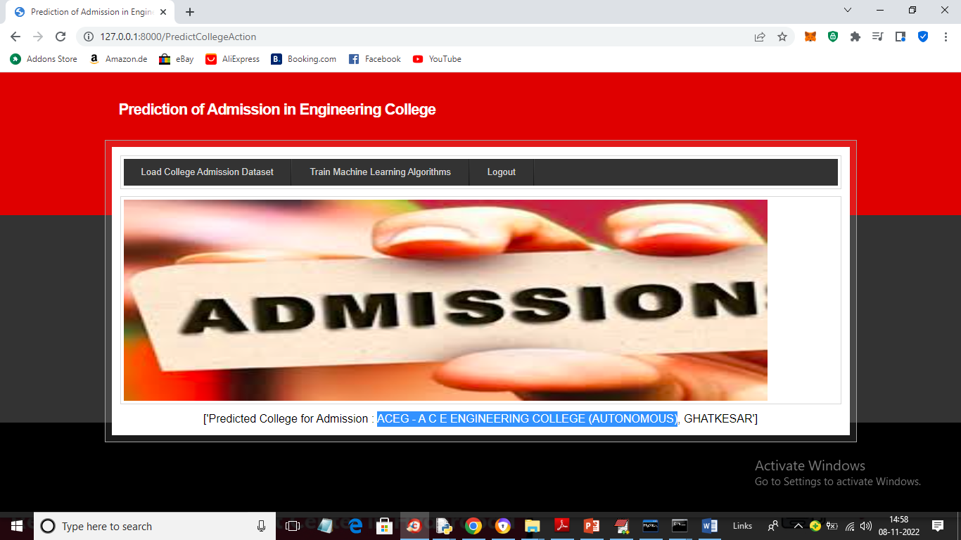

In above screen college predicted as ‘ACEG’ and similarly you can predicted other colleges also.